**Judul:** **Landing Page untuk Situs Web Makanan “Cateringz”**

**Open By Browse: http://127.0.0.1/myangkringan/index.html**

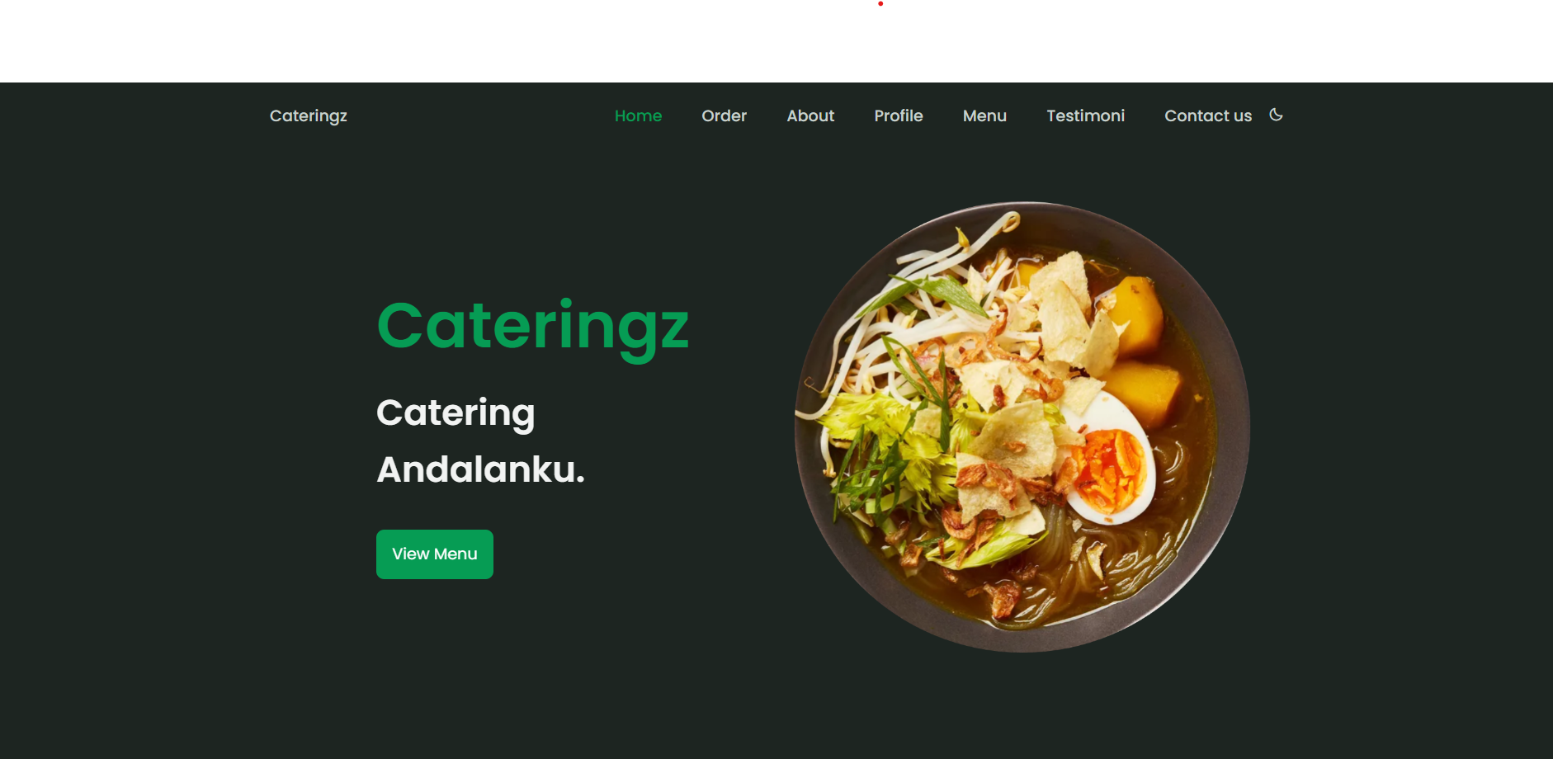

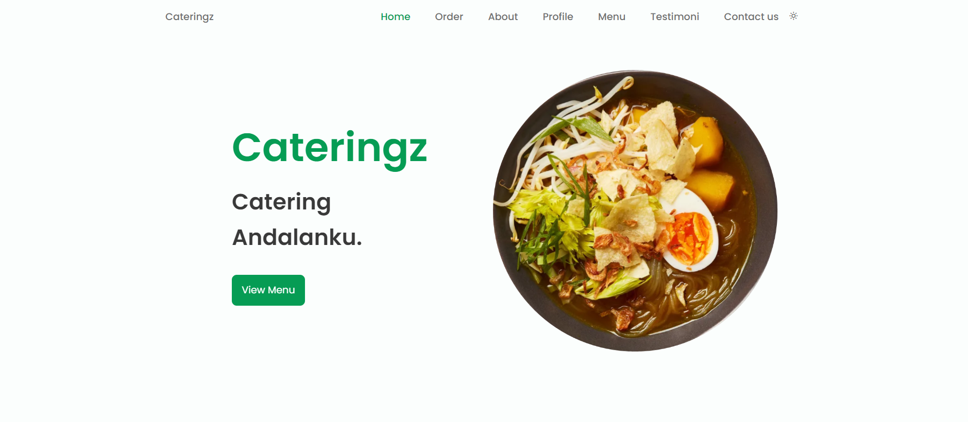

**Struktur Dasar Landing Page**

**Navbar Homepage:**

* Gambar: homepik.png
* Home
* Order(Sign Up)
* About
* Profile
* Menu
* Testimoni
* Contact us
* Gelap Terang

**Order**

**Navbar Order:**

* Formulir pemesanan
* Isi Data diri(Responsive)
* Indikator submission complete

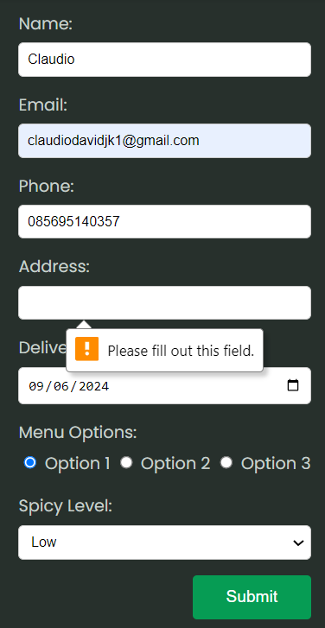

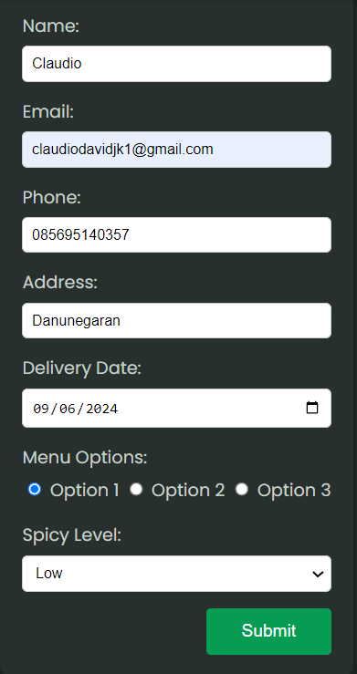

**About**

**Navbar About**

* Gambar: aboutus.jpg
* Penjelasan kenapa pilih cateringz

**Profile**

**Navbar Profile**

* Penjelasan services cateringz

**Menu**

**Navbar Menu**

* Gambar: box1.png, box2.png, box3.png
* Pilihan menu(opsi 1,2,3)

**Testimoni**

**Navbar Testimoni**

* Gambar: bene.png, boris.png, jegel.png, oki.png
* Box testimoni bisa di drag and drop
* Penampilan testimoni pelanggan

**Contact Us & Footer**

**Navbar Contact Us**

* Informasi kontak
* Link cepat (FAQ, Kebijakan Privasi, Syarat & Ketentuan)
* Ikon media sosial
* Alamat

